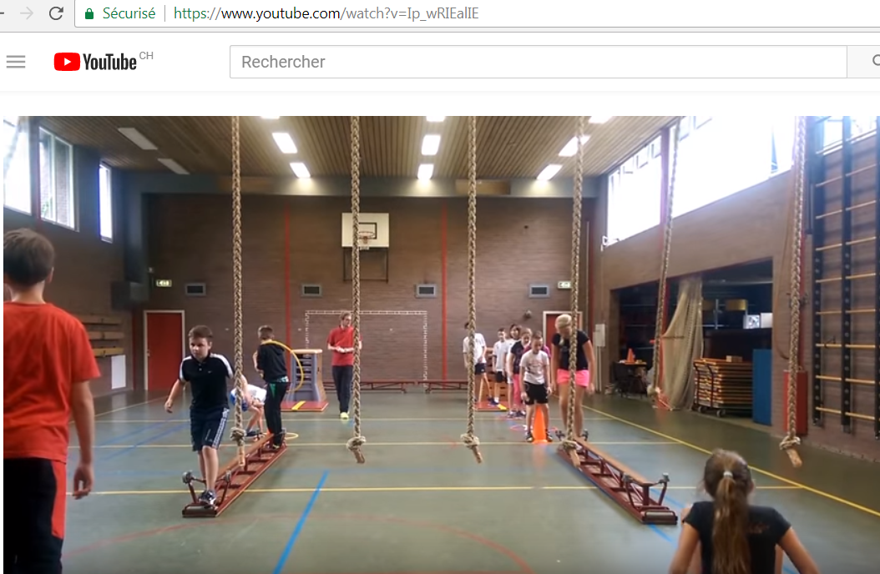

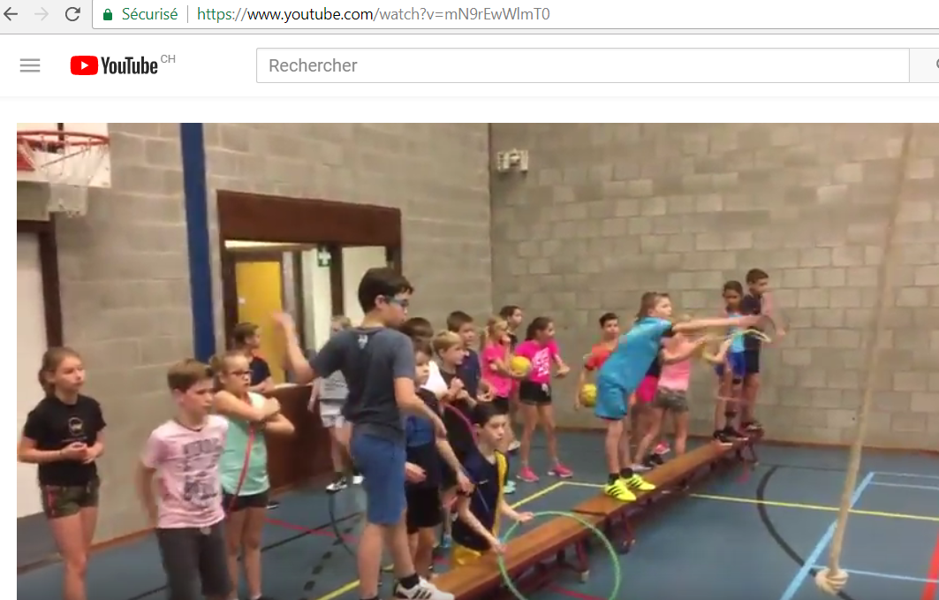
https://www.youtube.com/watch?v=mN9rEwWlmT0

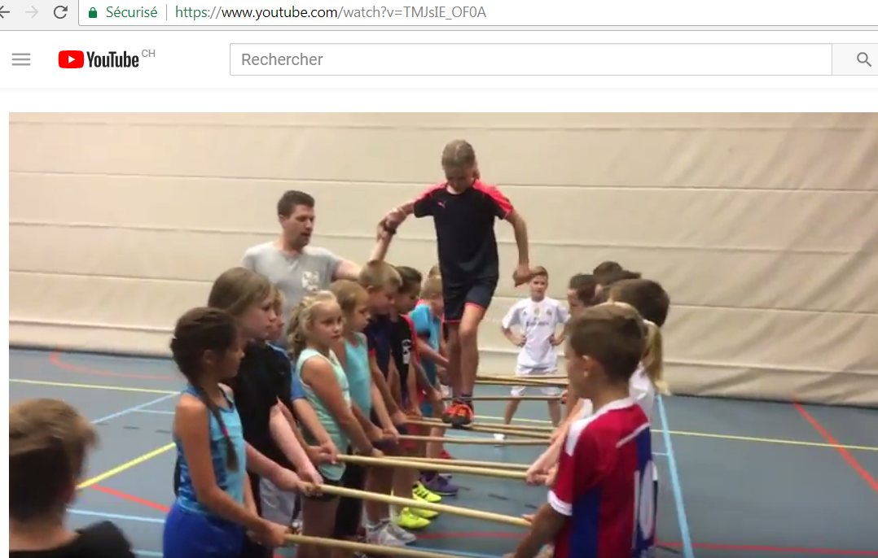
https://www.youtube.com/watch?v=TMJsIE_OF0A

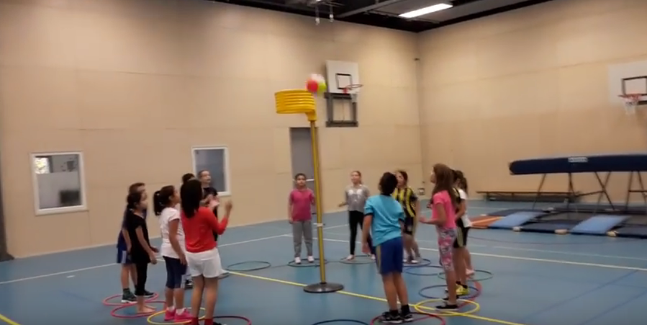

https://www.youtube.com/watch?v=fEoI3qHTVqw
Balle brûlée

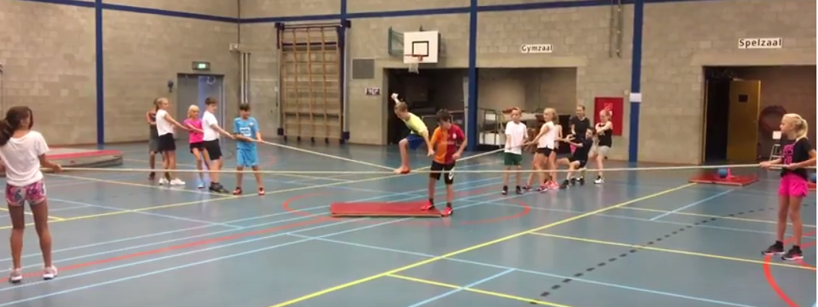

https://www.youtube.com/watch?v=UFsOxrxb2I4

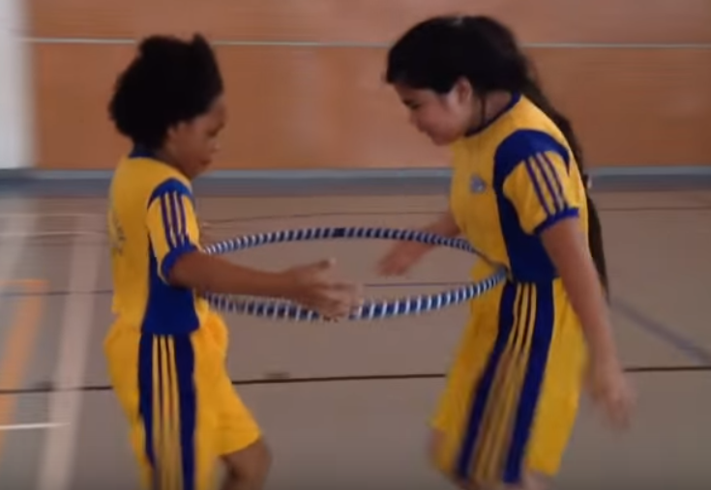
https://www.youtube.com/watch?v=hCJMEXfLdlM

https://www.youtube.com/watch?v=X3M33aoH9Ws

